Restaurants Industry
Name
Institution
Date

Restaurants Industry
My topic of interest is restaurants. A restaurant is a place where food and drinks are prepared and served to customers. It is an interesting topic since the restaurant industry has continued to evolve over the years and many people get their meals in restaurants. While most meals are prepared and consumed on the premises, many restaurants now have take-out and grocery delivery services.
The topic may benefit the reader since restaurants are more important now than they have ever been. Restaurants are now at the core of American life in the twenty-first century and are the last shining beacon of commercial industry, and they provide a large number of jobs as a result. The sector actually hires around 10% of the United States' total population. According to the National Restaurant Association, the industry will have employed around 15 million people by 2024 (Feldman, 2015). Like any other industry, restaurants can help with economic stability and mobility issues. Jobs in the sector are available to people from all walks of life. The barriers to entry in terms of qualification and schooling are minimal compared to other industries. Over the years restaurant industry has evolved around the following trends;
- Digitization
- Globalization
- Urbanization
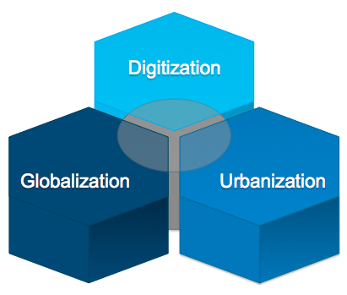
Types of restaurants
There are different types of restaurant but the main ones are;
- Fine Dining.
- Casual or Family-Style.
- Cruise Line.
- Food Hall.
- Food Truck.


The restaurants provide four types of foodservice systems which are:
- Conventional.
- Commissary.
- Ready prepared.
- Assembly or serve

Contact information
Contacts by Food Preference
List Name Contacts Date created
Vegetarians 7 Jan 16, 2021
Kids Menu 12 Dec 6, 2020
Holiday Menu 30 Dec 15, 2020

Link to the topic
https://medium.com/@EliFeldman/why-the-restaurant-industry-is-the-most-important-industry-in-todays-america-6a819f8f0ac9
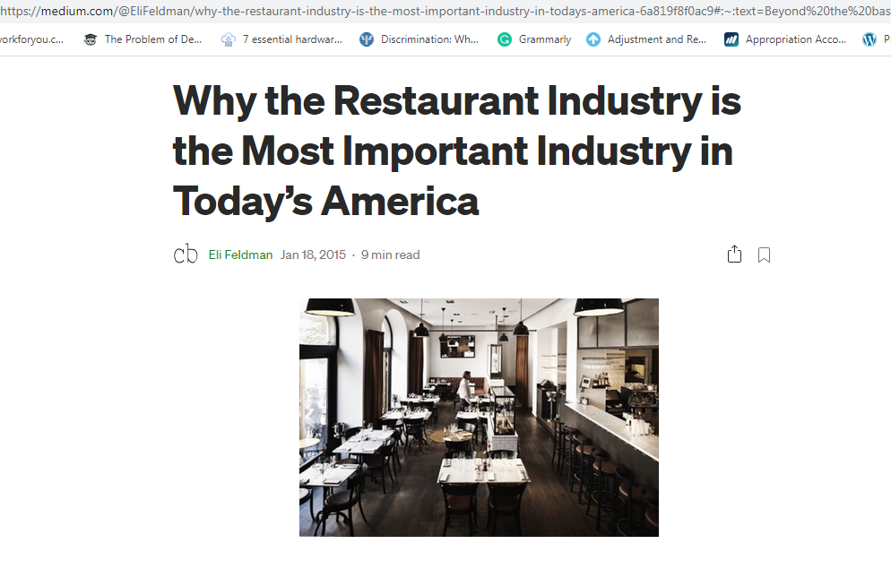

Reference
Feldman, E. (2015). Why the Restaurant Industry Is the Most Important Industry in Today’s America. Medium, January, 18. Retrieved from: https://medium.com/@EliFeldman/why-the-restaurant-industry-is-the-most-important-industry-in-todays-america-6a819f8f0ac9

